 | Commonwealth  of Australia | Gazette
No. FSC 136 Thursday 3 September 2020  Published by Commonwealth of Australia |  | Food Standards

Amendment No. 195
The following instruments are separate instruments in the Federal Register of Legislation and are known collectively in the Food Standards Gazette as Amendment No.195.

Table of contents

- Food Standards (Application A1184 – Glucoamylase from GM Aspergillus niger (donor Trametes cingulate)) Variation
- Food Standards (Application A1185 – Alpha-amylase from GM Aspergillus niger as a processing aid (enzyme)) Variation

ISSN 1446-9030
© Commonwealth of Australia 2020

This work is copyright. Apart from any use permitted under the Copyright Act 1968, all rights are reserved. Requests for authorisation to reproduce, publish or communicate this work should be made to The Information Officer, Food Standards Australia New Zealand, PO Box 5423, KINGSTON ACT 2604 or by email information@foodstandards.gov.au.

Food Standards (Application A1184 – Glucoamylase from GM Aspergillus niger (donor Trametes cingulata)) Variation

The Board of Food Standards Australia New Zealand gives notice of the making of this variation under section 92 of the Food Standards Australia New Zealand Act 1991. The variation commences on the date specified in clause 3 of this variation.

Dated 28 August 2020

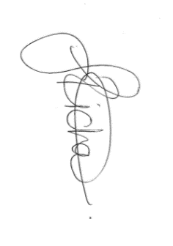
Joanna Richards
Standards Management Officer
Delegate of the Board of Food Standards Australia New Zealand

Note:

This variation will be published in the Commonwealth of Australia Gazette No. FSC 136 on 3 September 2020. This means that this date is the gazettal date for the purposes of clause 3 of the variation.

1 Name
This instrument is the Food Standards (Application A1184 – Glucoamylase from GM Aspergillus niger (donor Trametes cingulata)) Variation.
2 Variation to a standard in the Australia New Zealand Food Standards Code
The Schedule varies a Standard in the Australia New Zealand Food Standards Code.
3 Commencement
The variation commences on the date of gazettal.
Schedule
[1] Schedule 18 is varied by inserting in the table to subsection S18—9(3), in alphabetical order

Glucoamylase (EC 3.2.1.3) sourced from Aspergillus niger containing the glucoamylase gene from Trametes cingulata | For use in starch processing and the production of potable alcohol | GMP

Food Standards (Application A1185 – Alpha-amylase from GM Aspergillus niger as a processing aid (enzyme)) Variation

The Board of Food Standards Australia New Zealand gives notice of the making of this variation under section 92 of the Food Standards Australia New Zealand Act 1991. The variation commences on the date specified in clause 3 of this variation.

Dated 28 August 2020
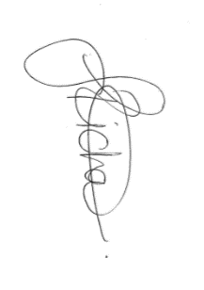

Joanna Richards
Standards Management Officer
Delegate of the Board of Food Standards Australia New Zealand

Note:

This variation will be published in the Commonwealth of Australia Gazette No. FSC 136 on 3 September 2020. This means that this date is the gazettal date for the purposes of clause 3 of the variation.

1 Name
This instrument is the Food Standards (Application A1185 – Alpha-amylase from GM Aspergillus niger as a processing aid (enzyme)) Variation.
2 Variation to a standard in the Australia New Zealand Food Standards Code
The Schedule varies a Standard in the Australia New Zealand Food Standards Code.
3 Commencement
The variation commences on the date of gazettal.
Schedule
[1] Schedule 18 is varied by inserting in the table to subsection S18—9(3), in alphabetical order

α-Amylase (EC 3.2.1.1) sourced from Aspergillus niger containing the α-Amylase gene from Rhizomucor pusillus | For use in starch processing and the production of potable alcohol | GMP

